

Project Submitted to the

**CENTRAL BOARD OF SECONDARY EDUCATION**

New Delhi.

Submitted by

**MUGILAN M**

In the academic year

2023-2024

Under the guidance of

**Mr. Swaminathan, M.Sc., B.Ed.,**

Department of Computer Science



**THAMARAI INTERNATIONAL SCHOOL   
 THANJVUR**

**INDEX PAGE**

|  |  |  |
| --- | --- | --- |
| **Serial no** | **Description** | **Page** |
| 1 | Bonafide Certificate | 2 |
| 2 | Acknowledgement | 3 |
| 3 | Python overview | 4 |
| 4 | Features of python | 5 |
| 5 | Advantages and installation of python | 6 |
| 6 | MySQL overview | 8 |
| 7 | Installation of MySQL | 9 |
| 8 | Hardware & Software requirements | 10 |
| 9 | Abstract of the project | 11 |
| 10 | Modules used and their purposes | 12 |
| 11 | Source code | 13 |
| 12 | Output screen | 22 |
| 13 | Bibliography | 27 |

# BONAFIDE CERTIFICATE

This is to certify that the project entitled **“MOS”** is a bonafide work carried out by **MUGILAN M** of Class XII (Computer

Science Stream) Thamarai International School, Affiliated to the Central Board of Secondary Education, New Delhi during the academic year 2023-2024 in partial

fulfilment of the requirements of the award of class XII Computer Science project

work.

**Teacher In-charge Senior Principal**

Submitted to All India Senior Secondary Examination held on_________________ at Thamarai International School, Thanjavur.

**Internal Examiner External Examiner**

# ACKNOWLEDGEMENT

The successful completion of any task would be incomplete without mentioning the

names of those persons who helped to make it possible.

I take this opportunity to express my gratitude in few words and respect to all those

who helped me in the completion of this project. It is my humble pleasure to

acknowledge my deep senses of gratitude to my respected computer science teacher **Mr. Swaminathan** for his valuable support, constant help and guidance at each and

every stage, without which this project would not have come forth.

I also register my sense of gratitude to our respected chairman **Mr. T. Venkatesan**,

and respected Senior Principal **Mrs. Jayashree Badrinath** for their immense

encouragement that made this project successful. I would also like to thank my

friends and my family for encouraging me during the course of this project.

Last, but not the least, I would like to thank CBSE for giving us the opportunity to

undertake this project.

# OVERVIEW OF PYTHON

Python is a general-purpose interpreted, interactive, object-oriented, and high-level programming language. It was created by Guido van Rossum during 1985-

1990. Like Perl, Python source code is also available under the GNU General Public License (GPL).

Python is a high-level, interpreted, interactive and object-oriented scripting language. Python is designed to be highly readable. It uses English keywords frequently where as other languages use punctuation, and it has fewer syntactical constructions than other languages.

Python is a MUST for students and working professionals to become a great Software Engineer specially when they are working in Web Development Domain. the key advantages of learning Python are:

1. Python is Interpreted − Python is processed at runtime by the interpreter. You do not need to compile your program before executing it. This is similar to PERL and PHP.
2. Python is Interactive − You can actually sit at a Python prompt and interact with the interpreter directly to write your programs.
3. Python is Object-Oriented − Python supports Object-Oriented style or technique of programming that encapsulates code within objects.

**Characteristics of Python:**

1. It supports functional and structured programming methods as well as OOP.
2. It can be used as a scripting language or can be compiled to byte-code for building large applications.
3. It provides very high-level dynamic data types and supports dynamic type checking.
4. It supports automatic garbage collection.
5. It can be easily integrated with C, C++, COM, ActiveX, CORBA, and Java.

**Python Features:**

1. Easy-to-learn − Python has few keywords, simple structure, and a clearly defined syntax. This allows the student to pick up the language quickly.
2. Easy-to-maintain − Python's source code is fairly easy-to-maintain.
3. A broad standard library − Python's bulk of the library is very portable and crossplatform compatible on UNIX, Windows, and Macintosh.
4. Interactive Mode − Python has support for an interactive mode which allows interactive testing and debugging of snippets of code.
5. Portable − Python can run on a wide variety of hardware platforms and has the same interface on all platforms.
6. Extendable − You can add low-level modules to the Python interpreter. These modules enable programmers to add to or customize their tools to be more

efficient.

1. Databases − Python provides interfaces to all major commercial databases.
2. GUI Programming − Python supports GUI applications that can be created and ported to many system calls, libraries and windows systems, such as Windows MFC, Macintosh, and the X Window system of Unix.
3. Scalable − Python provides a better structure and support for large programs than shell scripting.
4. Apart from the above-mentioned features, Python has a big list of good features, few are listed below −
5. It supports functional and structured programming methods as well as OOP.
6. It can be used as a scripting language or can be compiled to byte-code for building large applications.
7. It provides very high-level dynamic data types and supports dynamic type checking.
8. It supports automatic garbage collection.
9. It can be easily integrated with C, C++, COM, ActiveX, CORBA, and Java.

**ADVANTAGES OF PYTHON:**

* 1. Python is very easy-to-use
  2. Enhance Productivity
  3. Interpreted programming Language
  4. Support Open-source
  5. Simply portable
  6. Highly compatible with many other programming languages **INSTALLATION OF PYTHON:**
  7. Go to the official Python download page for Windows. Find a stable Python 3 release.
  8. Click the appropriate link for your system to download the executable file: Windows installer (64-bit) or Windows installer (32-bit).
  9. After the installer is downloaded, double-click the .exe file, for example python-3.10.10-amd64.exe, to run the Python installer.
  10. Select the Install launcher for all users checkbox, which enables all users of the computer to access the Python launcher application.
  11. Select the Add python.exe to PATH checkbox, which enables users to launch Python from the command line.
  12. Then click Install Now and go to Step 4 - Verify the Python Installation. To install other optional and advanced features, click Customize installation and continue.
  13. Click Next.
  14. The Advanced Options dialog displays.
  15. Select the options that suit your requirements:
      1. Install for all users: recommended if you’re not the only user on this computer
      2. Associate files with Python: recommended, because this option associates all the Python file types with the launcher or editor
      3. Create shortcuts for installed applications: recommended to enable shortcuts for Python applications
      4. Add Python to environment variables: recommended to enable launching Python
      5. Precompile standard library: not required, it might down the

installation

* + 1. Download debugging symbols and Download debug binaries:

recommended only if you plan to create C or C++ extensions

# SOFTWARE & HARDWARE REQUIREMENTS

**HARDWARE:**

1. Processor – Pentium(R) G2030@ 3.70 GHz
2. RAM: 4 GB
3. System Architecture: 32 or 64 bit Operating system
4. HDD: 500 GB **SOFTWARE:**
5. Operating system: Linux- Ubuntu 16.04 to 17.10, or Windows 7 to 11
6. IDE: Python 3.6 or higher
7. Database: MySQL Connector/Python 8.0 with MySQL Server 8.0, 5.7, and 5.6

# 

# ABSTRACT

The project **MOS** (**M**ugilan **O**perating **S**ystem) aims to create a suite of user-friendly applications developed primarily using Python, offering a range of functionalities including calculations, weather updates, dictionary services, and more. While not constituting an entire operating system, this collection of applications is designed to provide accessible and practical tools for various everyday tasks.

# MODULES USED AND THEIR PURPOSE

1. **Tkinter:** This framework provides Python users with a simple way to create GUI elements using the widgets found in the Tk toolkit. Tk widgets can be used to construct buttons, menus, data fields, etc.
2. **PIL:** The Python Imaging Library (PIL) is a library that provides extensive capabilities for opening, manipulating, and saving various image file formats in Python. Its primary purpose is to facilitate image processing tasks such as image creation, editing, enhancement, and analysis. Some of the key purposes and functionalities of PIL (which has been succeeded by the Pillow library)
3. **CSV:** CSV stands for Comma-Separated Values. It's a simple file format used to store tabular data, such as a spreadsheet or a database. The purpose of CSV files is to provide a way to organize and represent data in a plain text format, where each line corresponds to a row, and the values within each row are separated by commas.
4. **OS:** The os module in Python provides a way to interact with the operating system. It offers a range of functions to perform operating system-related tasks, such as file and directory operations, working with environment variables, process management, and more. The primary purpose of the os module is to provide a platform-independent interface for interacting with the underlying operating system.
5. **Random:** The random module in Python is used to generate random numbers. It provides various functions for generating random data, including integers, floating-point numbers, sequences, and more. The module is commonly used for tasks that require randomness, such as simulations, gaming, statistical sampling, and cryptographic applications.
6. **Pygame:** Pygame is a popular set of Python modules designed for writing video games. It's built on top of the Simple DirectMedia Layer (SDL), which provides low-level access to various audio, keyboard, mouse, and display components. Pygame simplifies game development by offering tools and libraries for handling graphics, sound, and user input.
7. **Time:** The time module in Python provides various time-related functions. It allows you to work with time, both in terms of time intervals and the current time.
8. **Datetime:** The datetime module in Python is used for dealing with dates, times, and time intervals. It provides classes and functions to work with dates and times, allowing for various operations like creating, manipulating, formatting, and performing arithmetic on dates and times.
9. **Winsound:** The winsound module is specific to Windows systems in Python and allows for simple sound playing and control capabilities. It offers basic sound-playing functionality and is primarily used for simple audio feedback within Windows environments.

**SOURCE CODE:**

**MAIN.py:**

import tkinter as tk

from tkinter import messagebox

from tkinter import *

from PIL import ImageTk, Image

import csv

import os

app = tk.Tk()

app.title("Welcome")

img = Image.open("black.png")

bg = ImageTk.PhotoImage(img)

app.geometry("1500x999")

# Add image

label = Label(app, image=bg)

label.place(x=0, y=0)

def on_username_entry_click(event):

if username_entry.get() == "Username":

username_entry.delete(0, "end")

username_entry.config(fg='white')

def on_username_focus_out(event):

if username_entry.get() == "":

username_entry.insert(0, "Username")

username_entry.config(fg='white')

def on_username_entry_click_1(event):

if username_entry1.get() == "Username":

username_entry1.delete(0, "end")

username_entry1.config(fg='white')

def on_username_focus_out_1(event):

if username_entry1.get() == "":

username_entry1.insert(0, "Username")

username_entry1.config(fg='white')

def on_password_entry_click(event):

if password_entry.get() == "Password":

password_entry.delete(0, "end")

password_entry.config(fg='white')

password_entry.config(show='●')

def on_password_focus_out(event):

if password_entry.get() == "":

password_entry.insert(0, "Password")

password_entry.config(fg='white')

password_entry.config(show='')

def on_password_entry_click_1(event):

if password_entry1.get() == "Password":

password_entry1.delete(0, "end")

password_entry1.config(fg='white')

password_entry1.config(show='')

def on_password_focus_out_1(event):

if password_entry1.get() == "":

password_entry1.insert(0, "Password")

password_entry1.config(fg='white')

password_entry1.config(show='')

def on_email_entry_click(event):

if email.get() == "Email":

email.delete(0, "end")

email.config(fg='white')

def on_email_focus_out(event):

if email.get() == "":

email.insert(0, "Email")

email.config(fg='white')

def chess():

os.system("python Chess.py")

def notepad():

os.system("python notepad.py")

def calculator():

os.system("python calculator.py")

def paint():

os.system("python paint.py")

def clock():

os.system("python clock.py")

def chatbot():

os.system("python chatbot.py")

def weather():

os.system("python weather.py")

def music():

os.system("python music_player.py")

def dict_app():

os.system("python dict_1.py")

def calander_app():

os.system("python calander.py")

def write_to_csv():

data = {

'username': username_entry1.get(),

"email": email.get(),

'password': password_entry1.get()}

with open('storage.csv', newline='', mode='a') as database:

csv_writer = csv.writer(database, delimiter=',', quotechar='"', quoting=csv.QUOTE_MINIMAL)

csv_writer.writerow([data['username'], data['password'], data['email']])

messagebox.showinfo("sign up Successful", "You have signed up in Successfully")

def sign__up():

global username_entry1, password_entry1, email

signup_window = Toplevel(app)

signup_window.title("Sign Up")

signup_window.geometry("1250x833")

signup_window.resizable(False, False)

# Load an image for the sign-up window

img_signup = Image.open("acc.png")

bg_signup = ImageTk.PhotoImage(img_signup)

# Create and place the Label widget with the image

label_signup = Label(signup_window, image=bg_signup)

label_signup.image = bg_signup # Keep a reference to the image to prevent it from being garbage collected

label_signup.pack()

username_entry1 = Entry(signup_window, bg="black", fg='white', font=('Arial 21'), bd=0)

username_entry1.insert(0, "Username")

username_entry1.bind("<FocusIn>", on_username_entry_click_1)

username_entry1.bind("<FocusOut>", on_username_focus_out_1)

username_entry1.place(x=490, y=310, height=50)

email = Entry(signup_window, bg="black", fg='white', font=('Arial 21'), bd=0)

email.insert(0, "Email")

email.bind("<FocusIn>", on_email_entry_click)

email.bind("<FocusOut>", on_email_focus_out)

email.place(x=490, y=380, height=50)

password_entry1 = Entry(signup_window, bg="black", fg='white', font=('Arial 21'), bd=0)

password_entry1.insert(0, "Password")

password_entry1.bind("<FocusIn>", on_password_entry_click_1)

password_entry1.bind("<FocusOut>", on_password_focus_out_1)

password_entry1.place(x=490, y=450, height=50)

click_btn1 = PhotoImage(file='button.png')

button1 = Button(signup_window, image=click_btn1, bd=0, command=write_to_csv)

button1.place(y=540, x=500)

signup_window.mainloop()

def update_image(new_image):

label_new_window.config(image=new_image)

label_new_window.image = new_image

# chess_label = Button(new_window, bd=0, image=chess_bg, command=chess)

# chess_label.image = chess_bg

# chess_label.place(x=250, y=277)

note_label = Button(new_window, bd=0, image=note_bg, command=notepad)

note_label.image = note_bg

note_label.place(x=423, y=277)

calculator_label = Button(new_window, bd=0, image=calculator_bg, command=calculator)

calculator_label.image = calculator_bg

calculator_label.place(x=780, y=277)

paint_label = Button(new_window, bd=0, image=paint_bg, command=paint)

paint_label.image = paint_bg

paint_label.place(x=949, y=455)

chatbot_label = Button(new_window, bd=0, image=chatbot_bg, command=chatbot)

chatbot_label.image = chatbot_bg

chatbot_label.place(x=600, y=282)

weather_label = Button(new_window, bd=0, image=weather_bg, command=weather)

weather_label.image = weather_bg

weather_label.place(x=423, y=455)

music_label = Button(new_window, bd=0, image=music_bg, command=music)

music_label.image = music_bg

music_label.place(x=249, y=455)

dict_label = Button(new_window, bd=0, image=dict_bg, command=dict_app)

dict_label.image = dict_bg

dict_label.place(x=609, y=455)

calander_label = Button(new_window, bd=0, image=calander_bg, command=calander_app)

calander_label.image = calander_bg

calander_label.place(x=782, y=452)

calander_label = Button(new_window, bd=0, image=calander_bg, command=calander_app)

calander_label.image = calander_bg

calander_label.place(x=782, y=452)

clock_label = Button(new_window, bd=0, image=clock_bg, command=clock)

clock_label.image = clock_bg

clock_label.place(x=952, y=282)

def login():

global bg_new_window_app, app_button, label_new_window, new_window, chess_bg, bg_new_window1,username_entry,password_entry

global chatbot_bg,note_bg,calculator_bg,paint_bg,weather_bg,music_bg,dict_bg,calander_bg,clock_bg

entered_username = username_entry.get()

entered_password = password_entry.get()

with open('storage.csv', newline='') as database:

csv_reader = csv.reader(database)

for row in csv_reader:

username = row[0]

password = row[1]

if entered_username == username and entered_password == password :

messagebox.showinfo("Login Successful", "You have logged in successfully")

app.destroy()

global new_window, bg_new_window1

new_window = tk.Tk()

new_window.title("Welcome, User!")

new_window.geometry("1250x833")

new_window.resizable(False, False)

# Add widgets and content to the new window here

img_new_window = Image.open("window_final.png")

bg_new_window = ImageTk.PhotoImage(img_new_window)

img_new_window1 = Image.open("window_final1.png")

bg_new_window1 = ImageTk.PhotoImage(img_new_window1)

# chess_img = Image.open("chess.png")

# chess_bg = ImageTk.PhotoImage(chess_img)

note_img = Image.open("note.png")

note_bg = ImageTk.PhotoImage(note_img)

calculator_img = Image.open("calculator.png")

calculator_bg = ImageTk.PhotoImage(calculator_img)

paint_img = Image.open("paint.png")

paint_bg = ImageTk.PhotoImage(paint_img)

chatbot_img = Image.open("chatbot.png")

chatbot_bg = ImageTk.PhotoImage(chatbot_img)

weather_img = Image.open("weather.png")

weather_bg = ImageTk.PhotoImage(weather_img)

music_img = Image.open("music_app.png")

music_bg = ImageTk.PhotoImage(music_img)

dict_img = Image.open("dict.png")

dict_bg = ImageTk.PhotoImage(dict_img)

calander_img = Image.open("calander_app.png")

calander_bg = ImageTk.PhotoImage(calander_img)

clock_img = Image.open("clock.png")

clock_bg = ImageTk.PhotoImage(clock_img)

# Create and place the Label widget with the background image

global label_new_window

label_new_window = Label(new_window, image=bg_new_window)

label_new_window.image = bg_new_window # Keep a reference to the image

label_new_window.place(x=0, y=0, relwidth=1, relheight=1)

app_button = Image.open("app_button.png")

bg_new_window_app = ImageTk.PhotoImage(app_button)

button = tk.Button(new_window, bd=0, image=bg_new_window_app, command=lambda: update_image(bg_new_window1))

button.place(y=735, x=580)

new_window.mainloop()

return # Exit the loop once a match is found

messagebox.showerror("Login Failed", "Invalid Username and Password")

username_entry = tk.Entry(bg="black", fg='white', font=('Arial 17'), bd=0)

username_entry.insert(0, "Username")

username_entry.bind("<FocusIn>", on_username_entry_click)

username_entry.bind("<FocusOut>", on_username_focus_out)

username_entry.place(y=315, x=611, width=300, height=40)

password_entry = tk.Entry(bg="black", fg='white', font=('Arial 17'), bd=0)

password_entry.insert(0, "Password")

password_entry.bind("<FocusIn>", on_password_entry_click)

password_entry.bind("<FocusOut>", on_password_focus_out)

password_entry.place(y=385, x=610, width=300, height=40)

click_btn = PhotoImage(file='button.png')

click_btn2 = PhotoImage(file='create_acc.png')

button = tk.Button(image=click_btn, bd=0, command=login)

button.place(y=477, x=607)

signup = tk.Button(image=click_btn2, command=sign__up, bd=0)

signup.place(y=582, x=850)

app.mainloop()

**Dict_1.py:**

import tkinter as tk

from tkinter import messagebox

# Dictionary data

dictionary = {

"apple": ["A fruit with a sweet or tart taste.", "A technology company."],

"banana": ["A long, curved fruit that grows in clusters.", "A term for a yellow color."],

"cherry": ["A small, round fruit that is typically red or black.", "A decorative wood with a reddish-brown color."],

# Add more words and their meanings as needed

}

def lookup_word():

word = entry.get().lower()

meanings = dictionary.get(word, ["Word not found in the dictionary."])

meanings_text = "\n".join(meanings)

messagebox.showinfo("Meanings", meanings_text)

def add_word():

word = entry.get().lower()

definition = entry_definition.get()

if word in dictionary:

dictionary[word].append(definition)

else:

dictionary[word] = [definition]

messagebox.showinfo("Success", "Meaning added to the dictionary.")

def delete_word():

word = entry.get().lower()

if word in dictionary:

del dictionary[word]

messagebox.showinfo("Success", "Word deleted from the dictionary.")

else:

messagebox.showerror("Error", "Word not found in the dictionary.")

# Create the main application window

root = tk.Tk()

root.title("Dictionary App")

p1 = tk.PhotoImage(file = 'dict.png')

root.iconphoto(False, p1)

# Create UI elements

label = tk.Label(root, text="Enter a word:")

label.pack(pady=10)

entry = tk.Entry(root)

entry.pack(pady=5)

lookup_button = tk.Button(root, text="Lookup", command=lookup_word)

lookup_button.pack(pady=5, padx=10)

# Additional UI elements for adding and deleting words

add_label = tk.Label(root, text="Enter a new meaning:")

add_label.pack(pady=10)

entry_definition = tk.Entry(root)

entry_definition.pack(pady=5)

add_button = tk.Button(root, text="Add Meaning", command=add_word)

add_button.pack(pady=5, padx=10)

delete_button = tk.Button(root, text="Delete Word", command=delete_word)

delete_button.pack(pady=5, padx=10)

# Run the application

root.mainloop()

**Weather.py:**

import tkinter as tk

from tkinter import messagebox

from PIL import Image, ImageTk

import random

# Simulated weather data generator

def generate_weather():

temperature = round(random.uniform(-20, 40), 1)

humidity = round(random.uniform(30, 90), 1)

weather_conditions = {

'Clear': '☀️',

'Partly Cloudy': '⛅',

'Cloudy': '☁️',

'Rainy': '🌧️',

'Stormy': '⛈️',

'Snowy': '❄️'

}

condition = random.choice(list(weather_conditions.keys()))

return {

'temperature': temperature,

'humidity': humidity,

'condition': condition,

'icon': weather_conditions[condition]

}

# Function to display the weather

def display_weather():

city = city_entry.get()

if not city:

messagebox.showerror("Error", "Please enter a city.")

return

weather_data = generate_weather()

messagebox.showinfo("Weather Information",

f"City: {city}\n"

f"Date: {date_entry.get()}\n"

f"Temperature: {weather_data['temperature']}°C\n"

f"Humidity: {weather_data['humidity']}%\n"

f"Condition: {weather_data['condition']} {weather_data['icon']}")

# Create the main application window

root = tk.Tk()

root.title("Simulated Weather App")

p1 = tk.PhotoImage(file = 'weather.png')

root.iconphoto(False, p1)

# Create GUI components

label = tk.Label(root, text="Simulated Weather App", font=("Helvetica", 16))

label.pack(pady=10)

city_label = tk.Label(root, text="Enter city:")

city_label.pack(pady=5)

city_entry = tk.Entry(root)

city_entry.pack(pady=5)

date_label = tk.Label(root, text="Enter date:")

date_label.pack(pady=5)

date_entry = tk.Entry(root)

date_entry.pack(pady=5)

fetch_button = tk.Button(root, text="Fetch Weather", command=display_weather)

fetch_button.pack(pady=10)

# Run the main event loop

root.mainloop()

**Clock.py:**

import tkinter as tk

from tkinter import messagebox

import time

import winsound

# Initialize alarm_time and timer_duration as global variables

alarm_time = ""

timer_duration = 0

# Function to update the clock

def update_clock():

current_time = time.strftime('%H:%M:%S')

clock_label.config(text=current_time)

check_alarm()

root.after(1000, update_clock) # Update every second

# Function to set an alarm

def set_alarm():

global alarm_time

alarm_time = entry_alarm.get()

messagebox.showinfo("Alarm Set", f"Alarm set for {alarm_time}")

# Function to start the timer

# Function to start the timer

def start_timer():

global timer_duration

timer_input = entry_timer.get()

if timer_input.isdigit():

timer_duration = int(timer_input)

messagebox.showinfo("Timer Started", f"Timer set for {timer_duration} seconds")

root.after(timer_duration * 1000, lambda: show_message("Timer Finished", "Timer finished"))

else:

messagebox.showerror("Invalid Input", "Please enter a valid integer for the timer.")

# Function to check the alarm

def check_alarm():

current_time = time.strftime('%H:%M:%S')

if current_time == alarm_time:

play_sound()

show_message("Alarm", "Alarm time reached")

# Function to play a sound

def play_sound():

winsound.Beep(1000, 1000) # Beep at 1000 Hz for 1 second

# Function to show a message box

def show_message(title, message):

messagebox.showinfo(title, message)

# Create the main application window

root = tk.Tk()

root.title('Clock, Alarm, and Timer App')

p1 = tk.PhotoImage(file = 'clock.png')

root.iconphoto(False, p1)

# Clock label

clock_label = tk.Label(root, font=('Arial', 24), bg='white', fg='black')

clock_label.pack(pady=10)

# Alarm section

tk.Label(root, text="Set Alarm (HH:MM:SS):").pack(pady=5)

entry_alarm = tk.Entry(root)

entry_alarm.pack(pady=5)

tk.Button(root, text="Set Alarm", command=set_alarm).pack(pady=5)

# Timer section

tk.Label(root, text="Set Timer (seconds):").pack(pady=5)

entry_timer = tk.Entry(root)

entry_timer.pack(pady=5)

tk.Button(root, text="Start Timer", command=start_timer).pack(pady=5)

# Run the clock update function

update_clock()

# Start the main event loop

root.mainloop()

**calculator.py:**

import tkinter

from tkinter import *

from tkinter import messagebox

# setting the initial values of some variables

var = ""

A = 0

operator = ""

# defining the function for Button 1

def button_1_is_Clicked():

global var

var = var + "1"

the_data.set(var)

# defining the function for Button 2

def button_2_is_Clicked():

global var

var = var + "2"

the_data.set(var)

# defining the function for Button 3

def button_3_is_Clicked():

global var

var = var + "3"

the_data.set(var)

# defining the function for Button 4

def button_4_is_Clicked():

global var

var = var + "4"

the_data.set(var)

# defining the function for Button 5

def button_5_is_Clicked():

global var

var = var + "5"

the_data.set(var)

# defining the function for Button 6

def button_6_is_Clicked():

global var

var = var + "6"

the_data.set(var)

# defining the function for Button 7

def button_7_is_Clicked():

global var

var = var + "7"

the_data.set(var)

# defining the function for Button 8

def button_8_is_Clicked():

global var

var = var + "8"

the_data.set(var)

# defining the function for Button 9

def button_9_is_Clicked():

global var

var = var + "9"

the_data.set(var)

# defining the function for Button 0

def button_0_is_Clicked():

global var

var = var + "0"

the_data.set(var)

# defining the function for Button +

def button_Add_is_Clicked():

global A

global var

global operator

A = float(var)

operator = "+"

var = var + "+"

the_data.set(var)

# defining the function for Button -

def button_Sub_is_Clicked():

global A

global var

global operator

A = float(var)

operator = "-"

var = var + "-"

the_data.set(var)

# defining the function for Button *

def button_Mul_is_Clicked():

global A

global var

global operator

A = float(var)

operator = "*"

var = var + "*"

the_data.set(var)

# defining the function for Button /

def button_Div_is_Clicked():

global A

global var

global operator

A = float(var)

operator = "/"

var = var + "/"

the_data.set(var)

# defining the function for Button =

def button_Equal_is_Clicked():

global A

global var

global operator

A = float(var)

operator = "="

var = var + "="

the_data.set(var)

# defining the function for Button C

def button_C_is_Clicked():

global A

global var

global operator

var = ""

A = 0

operator = ""

the_data.set(var)

# defining the function to display result

def res():

global A

global operator

global var

var2 = var

if operator == "+":

a = float((var2.split("+")[1]))

x = A + a

the_data.set(x)

var = str(x)

elif operator == "-":

a = float((var2.split("-")[1]))

x = A - a

the_data.set(x)

var = str(x)

elif operator == "*":

a = float((var2.split("*")[1]))

x = A * a

the_data.set(x)

var = str(x)

elif operator == "/":

a = float((var2.split("/")[1]))

if a == 0:

messagebox.showerror("Division by 0 Not Allowed.")

A == ""

var = ""

the_data.set(var)

else:

x = float(A/a)

the_data.set(x)

var = str(x)

# creating an object of the Tk() class

guiWindow = tkinter.Tk()

# setting the size of the window

guiWindow.geometry("320x500+400+400")

# disabling the resize option for better UI

guiWindow.resizable(0, 0)

# setting the title of the Calculator window

guiWindow.title("Calculator")

p1 = PhotoImage(file = 'calculator.png')

guiWindow.iconphoto(False, p1)

# creating the label for the window

the_data = StringVar()

guiLabel = Label(

guiWindow,

text = "Label",

anchor = SE,

font = ("Cambria Math", 20),

textvariable = the_data,

background = "#ffffff",

fg = "#000000"

)

# using the pack() method

guiLabel.pack(expand = True, fill = "both")

# creating the frames for the buttons

# first frame

frameOne = Frame(guiWindow, bg = "#000000")

frameOne.pack(expand = True, fill = "both") # frame can expand if it gets some space

# second frame

frameTwo = Frame(guiWindow, bg = "#000000")

frameTwo.pack(expand = True, fill = "both")

# third frame

frameThree = Frame(guiWindow, bg = "#000000")

frameThree.pack(expand = True, fill = "both")

# fourth frame

frameFour = Frame(guiWindow, bg = "#000000")

frameFour.pack(expand = True, fill = "both")

# creating buttons for each frame

# buttons for first frame

# button 1

buttonONE = Button(

frameOne,

text = "1",

font = ("Cambria", 22),

relief = GROOVE,

border = 0,

command = button_1_is_Clicked

)

# placing buttons side by side

buttonONE.pack(side = LEFT, expand = True, fill = "both")

# button 2

buttonTWO = Button(

frameOne,

text = "2",

font = ("Cambria", 22),

relief = GROOVE,

border = 0,

command = button_2_is_Clicked

)

# placing buttons side by side

buttonTWO.pack(side = LEFT, expand = True, fill = "both")

# button 3

buttonTHREE = Button(

frameOne,

text = "3",

font = ("Cambria", 22),

relief = GROOVE,

border = 0,

command = button_3_is_Clicked

)

# placing buttons side by side

buttonTHREE.pack(side = LEFT, expand = True, fill = "both")

# button C

buttonC = Button(

frameOne,

text = "C",

font = ("Cambria", 22),

relief = GROOVE,

border = 0,

command = button_C_is_Clicked

)

# placing buttons side by side

buttonC.pack(side = LEFT, expand = True, fill = "both")

# buttons for second frame

# button 4

buttonFOUR = Button(

frameTwo,

text = "4",

font = ("Cambria", 22),

relief = GROOVE,

border = 0,

command = button_4_is_Clicked

)

# placing buttons side by side

buttonFOUR.pack(side = LEFT, expand = True, fill = "both")

# button 5

buttonFIVE = Button(

frameTwo,

text = "5",

font = ("Cambria", 22),

relief = GROOVE,

border = 0,

command = button_5_is_Clicked

)

# placing buttons side by side

buttonFIVE.pack(side = LEFT, expand = True, fill = "both")

# button 6

buttonSIX = Button(

frameTwo,

text = "6",

font = ("Cambria", 22),

relief = GROOVE,

border = 0,

command = button_6_is_Clicked

)

# placing buttons side by side

buttonSIX.pack(side = LEFT, expand = True, fill = "both")

# button +

buttonADD = Button(

frameTwo,

text = "+",

font = ("Cambria", 22),

relief = GROOVE,

border = 0,

command = button_Add_is_Clicked

)

# placing buttons side by side

buttonADD.pack(side = LEFT, expand = True, fill = "both")

# buttons for third frame

# button 7

buttonSEVEN = Button(

frameThree,

text = "7",

font = ("Cambria", 22),

relief = GROOVE,

border = 0,

command = button_7_is_Clicked

)

# placing buttons side by side

buttonSEVEN.pack(side = LEFT, expand = True, fill = "both")

# button 8

buttonEIGHT = Button(

frameThree,

text = "8",

font = ("Cambria", 22),

relief = GROOVE,

border = 0,

command = button_8_is_Clicked

)

# placing buttons side by side

buttonEIGHT.pack(side = LEFT, expand = True, fill = "both")

# button 9

buttonNINE = Button(

frameThree,

text = "9",

font = ("Cambria", 22),

relief = GROOVE,

border = 0,

command = button_9_is_Clicked

)

# placing buttons side by side

buttonNINE.pack(side = LEFT, expand = True, fill = "both")

# button -

buttonSUB = Button(

frameThree,

text = "-",

font = ("Cambria", 22),

relief = GROOVE,

border = 0,

command = button_Sub_is_Clicked

)

# placing buttons side by side

buttonSUB.pack(side = LEFT, expand = True, fill = "both")

# buttons for fourth frame

# button 0

buttonZERO = Button(

frameFour,

text = "0",

font = ("Cambria", 22),

relief = GROOVE,

border = 0,

command = button_0_is_Clicked

)

# placing buttons side by side

buttonZERO.pack(side = LEFT, expand = True, fill = "both")

# button *

buttonMUL = Button(

frameFour,

text = "*",

font = ("Cambria", 22),

relief = GROOVE,

border = 0,

command = button_Mul_is_Clicked

)

# placing buttons side by side

buttonMUL.pack(side = LEFT, expand = True, fill = "both")

# button /

buttonDIV = Button(

frameFour,

text = "/",

font = ("Cambria", 22),

relief = GROOVE,

border = 0,

command = button_Div_is_Clicked

)

# placing buttons side by side

buttonDIV.pack(side = LEFT, expand = True, fill = "both")

# button +

buttonEQUAL = Button(

frameFour,

text = "=",

font = ("Cambria", 22),

relief = GROOVE,

border = 0,

command = res

)

# placing buttons side by side

buttonEQUAL.pack(side = LEFT, expand = True, fill = "both")

# running the GUI

guiWindow.mainloop()

**notepad.py:**

import tkinter as tk

from tkinter import filedialog

def new_file():

text.delete("1.0", tk.END)

def open_file():

file_path = filedialog.askopenfilename(filetypes=[("Text Files", "*.txt"), ("All Files", "*.*")])

if file_path:

with open(file_path, "r") as file:

text.delete("1.0", tk.END)

text.insert("1.0", file.read())

def save_file():

file_path = filedialog.asksaveasfilename(defaultextension=".txt", filetypes=[("Text Files", "*.txt"), ("All Files", "*.*")])

if file_path:

with open(file_path, "w") as file:

file.write(text.get("1.0", tk.END))

def exit_application():

root.destroy()

root = tk.Tk()

root.title("Notepad")

p1 = tk.PhotoImage(file = 'Notepad.png')

root.iconphoto(False, p1)

text = tk.Text(root,font=('Arial 14'), wrap="word")

text.pack(expand=True, fill="both")

menu_bar = tk.Menu(root)

file_menu = tk.Menu(menu_bar, tearoff=0)

file_menu.add_command(label="New", command=new_file)

file_menu.add_command(label="Open", command=open_file)

file_menu.add_command(label="Save", command=save_file)

file_menu.add_separator()

file_menu.add_command(label="Exit", command=exit_application)

menu_bar.add_cascade(label="File", menu=file_menu)

root.config(menu=menu_bar)

root.mainloop()

**chatbot.py:**

import tkinter as tk

import datetime

def on_submit(event=None):

user_input = input_field.get()

output_field.config(state='normal')

output_field.insert('end', 'User: ' + user_input + '\n', 'black')

if user_input in ['hi',"hey"]:

output_field.insert('end', 'Hello, how can I help you?\n', 'blue')

elif user_input == 'how are you':

output_field.insert('end', 'I am Okay. How about you?\n', 'blue')

elif user_input == 'how old are you':

output_field.insert('end', 'My creator just brought me to life in front of you. I am not much older than 10 minutes.\n', 'blue')

elif user_input == 'what time is it':

now = datetime.datetime.now()

output_field.insert('end', "It's "+ now.strftime("%H:%M:%S %p")+'\n', 'blue')

elif user_input == 'bye':

output_field.insert('end', 'Goodbye, have a nice day!\n', 'blue')

elif user_input == 'who is hod and gui helper of this project':

output_field.insert('end', 'Suriya thiru.T\n', 'blue')

elif user_input == 'who is your creator?':

output_field.insert('end', 'Mugilan.M\n', 'blue')

else:

output_field.insert('end', 'I am sorry, I do not understand.\n', 'blue')

input_field.delete(0, 'end')

output_field.config(state='disabled')

root = tk.Tk()

root.title("Chatbot")

p1 = tk.PhotoImage(file = 'chat.png')

root.iconphoto(False, p1)

output_frame = tk.Frame(root)

output_frame.pack(side='top', fill='both', expand=True)

output_label = tk.Label(output_frame, text="Chatbot:")

output_label.pack(side='left', padx=5, pady=5)

output_field = tk.Text(output_frame)

output_field.pack(side='left', fill='both', expand=True, padx=5, pady=5)

output_field.config(state='disabled')

output_field.tag_config('blue', foreground='blue')

output_field.tag_config('red', foreground='red')

output_field.config(font=("Futura", 16))

input_frame = tk.Frame(root)

input_frame.pack(side='bottom', fill='x')

input_label = tk.Label(input_frame, text="User:")

input_label.pack(side='left', padx=5, pady=5)

input_field = tk.Entry(input_frame, width=150)

input_field.pack(side='left', padx=5, pady=5)

input_field.bind("<Return>", on_submit)

submit_button = tk.Button(input_frame, text="Submit", command=on_submit)

submit_button.pack(side='left')

root.mainloop()

**music_player.py:**

import tkinter as tk

from tkinter import filedialog

import pygame

from PIL import Image, ImageTk

playlist = []

current_track_index = 0

def add_song():

file_path = filedialog.askopenfilename(filetypes=[("Audio Files", "*.mp3")])

if file_path:

playlist.append(file_path)

def play_music():

global current_track_index

if playlist:

pygame.mixer.music.load(playlist[current_track_index])

pygame.mixer.music.play()

def pause_music():

pygame.mixer.music.pause()

def stop_music():

pygame.mixer.music.stop()

def play_next():

global current_track_index

if playlist:

current_track_index = (current_track_index + 1) % len(playlist)

play_music()

def play_previous():

global current_track_index

if playlist:

current_track_index = (current_track_index - 1) % len(playlist)

play_music()

# Initialize Pygame mixer

pygame.init()

pygame.mixer.init()

root = tk.Tk()

root.title("Music Player")

p1 = tk.PhotoImage(file = 'music_app.png')

root.iconphoto(False, p1)

root.configure(bg="#2E2E2E")

img = Image.open("music_player.png")

bg = ImageTk.PhotoImage(img)

root.geometry("640x360")

root.resizable(False,False)

# Add image

label = tk.Label(root, image=bg)

label.place(x=0, y=0)

# Text styles

label_style = {"font": ("Arial", 12), "fg": "#FFFFFF", "bg": "#2E2E2E"}

# Buttons with images

play_button_img = Image.open("play.png")

play_photo = ImageTk.PhotoImage(play_button_img)

pause_button_img = Image.open("pause.png")

pause_button_img = pause_button_img.resize((50, 50))

pause_photo = ImageTk.PhotoImage(pause_button_img)

stop_button_img = Image.open("stop.png")

stop_button_img = stop_button_img.resize((50, 50))

stop_photo = ImageTk.PhotoImage(stop_button_img)

next_button_img = Image.open("next.png")

next_photo = ImageTk.PhotoImage(next_button_img)

prev_button_img = Image.open("prev.png")

prev_photo = ImageTk.PhotoImage(prev_button_img)

add_button_img = Image.open("add.png")

add_button_img = add_button_img.resize((50, 50))

add_photo = ImageTk.PhotoImage(add_button_img)

# Buttons with images

play_button = tk.Button(root, image=play_photo, command=play_music, bd=0)

play_button.place(x=260,y=240)

next_button = tk.Button(root, image=next_photo, command=play_next, borderwidth=0)

next_button.place(x=430,y=260)

prev_button = tk.Button(root, image=prev_photo, command=play_previous, borderwidth=0)

prev_button.place(x=140,y=260)

add_button = tk.Button(root, image=add_photo, command=add_song,borderwidth=0)

add_button.place(x= 550,y=25)

root.mainloop()

**paint.py:**

import tkinter as tk

from tkinter import ttk

canvas = None

selected_tool = "pen"

selected_color = "black"

selected_size = 2

selected_pen_type = "line"

prev_x = None

prev_y = None

def setup_canvas(root):

global canvas

canvas_width = 800

canvas_height = 600

canvas = tk.Canvas(root, width=canvas_width, height=canvas_height, bg="white", bd=3, relief=tk.SUNKEN)

canvas.pack(side=tk.LEFT, fill=tk.BOTH, expand=True)

def setup_navbar(root):

navbar = tk.Menu(root)

root.config(menu=navbar)

file_menu = tk.Menu(navbar, tearoff=False)

navbar.add_cascade(label="File", menu=file_menu)

file_menu.add_command(label="Save Snapshot", command=take_snapshot)

file_menu.add_separator()

file_menu.add_command(label="Exit", command=root.quit)

edit_menu = tk.Menu(navbar, tearoff=False)

navbar.add_cascade(label="Edit", menu=edit_menu)

edit_menu.add_command(label="Undo", command=undo)

def setup_tools(root):

global selected_tool, selected_color, selected_size, selected_pen_type

tool_frame = ttk.LabelFrame(root, text="Tools")

tool_frame.pack(side=tk.RIGHT, padx=5, pady=5, fill=tk.Y)

pen_button = ttk.Button(tool_frame, text="Pen", command=select_pen_tool)

pen_button.pack(side=tk.TOP, padx=5, pady=5)

eraser_button = ttk.Button(tool_frame, text="Eraser", command=select_eraser_tool)

eraser_button.pack(side=tk.TOP, padx=5, pady=5)

brush_size_label = ttk.Label(tool_frame, text="Brush Size:")

brush_size_label.pack(side=tk.TOP, padx=5, pady=5)

brush_size_combobox = ttk.Combobox(tool_frame, values=[2, 4, 6, 8], state="readonly")

brush_size_combobox.current(0)

brush_size_combobox.pack(side=tk.TOP, padx=5, pady=5)

brush_size_combobox.bind("<<ComboboxSelected>>", lambda event: select_size(int(brush_size_combobox.get())))

color_label = ttk.Label(tool_frame, text="Color:")

color_label.pack(side=tk.TOP, padx=5, pady=5)

color_combobox = ttk.Combobox(tool_frame, values=["black", "red", "green", "blue", "yellow", "orange", "purple"], state="readonly")

color_combobox.current(0)

color_combobox.pack(side=tk.TOP, padx=5, pady=5)

color_combobox.bind("<<ComboboxSelected>>", lambda event: select_color(color_combobox.get()))

pen_type_label = ttk.Label(tool_frame, text="Pen Type:")

pen_type_label.pack(side=tk.TOP, padx=5, pady=5)

pen_type_combobox = ttk.Combobox(tool_frame, values=["line", "round", "square", "arrow", "diamond"], state="readonly")

pen_type_combobox.current(0)

pen_type_combobox.pack(side=tk.TOP, padx=5, pady=5)

pen_type_combobox.bind("<<ComboboxSelected>>", lambda event: select_pen_type(pen_type_combobox.get()))

clear_button = ttk.Button(tool_frame, text="Clear Canvas", command=clear_canvas)

clear_button.pack(side=tk.TOP, padx=5, pady=5)

def setup_events():

canvas.bind("<B1-Motion>", draw)

canvas.bind("<ButtonRelease-1>", release)

def select_pen_tool():

global selected_tool

selected_tool = "pen"

def select_eraser_tool():

global selected_tool

selected_tool = "eraser"

def select_size(size):

global selected_size

selected_size = size

def select_color(color):

global selected_color

selected_color = color

def select_pen_type(pen_type):

global selected_pen_type

selected_pen_type = pen_type

def draw(event):

global prev_x, prev_y

if selected_tool == "pen":

if prev_x is not None and prev_y is not None:

if selected_pen_type == "line":

canvas.create_line(prev_x, prev_y, event.x, event.y, fill=selected_color,

width=selected_size, smooth=True)

elif selected_pen_type == "round":

x1 = event.x - selected_size

y1 = event.y - selected_size

x2 = event.x + selected_size

y2 = event.y + selected_size

canvas.create_oval(x1, y1, x2, y2, fill=selected_color, outline=selected_color)

elif selected_pen_type == "square":

x1 = event.x - selected_size

y1 = event.y - selected_size

x2 = event.x + selected_size

y2 = event.y + selected_size

canvas.create_rectangle(x1, y1, x2, y2, fill=selected_color, outline=selected_color)

elif selected_pen_type == "arrow":

x1 = event.x - selected_size

y1 = event.y - selected_size

x2 = event.x + selected_size

y2 = event.y + selected_size

canvas.create_polygon(x1, y1, x1, y2, event.x, y2, fill=selected_color, outline=selected_color)

elif selected_pen_type == "diamond":

x1 = event.x - selected_size

y1 = event.y

x2 = event.x

y2 = event.y - selected_size

x3 = event.x + selected_size

y3 = event.y

x4 = event.x

y4 = event.y + selected_size

canvas.create_polygon(x1, y1, x2, y2, x3, y3, x4, y4, fill=selected_color, outline=selected_color)

prev_x = event.x

prev_y = event.y

def release(event):

global prev_x, prev_y

prev_x = None

prev_y = None

def clear_canvas():

canvas.delete("all")

def take_snapshot():

canvas.postscript(file="snapshot.eps")

def undo():

items = canvas.find_all()

if items:

canvas.delete(items[-1])

if __name__ == "__main__":

root = tk.Tk()

root.title("Paint")

p1 = tk.PhotoImage(file = 'paint.png')

root.iconphoto(False, p1)

setup_canvas(root)

setup_navbar(root)

setup_tools(root)

setup_events()

root.mainloop()

**calander.py:**

import tkinter as tk

from datetime import datetime, timedelta

from tkinter import messagebox

# Create Object

root = tk.Tk()

root.title("Calendar")

p1 = tk.PhotoImage(file = 'calander_app.png')

root.iconphoto(False, p1)

# Global variables

current_date = datetime.now()

selected_date = current_date

# Function to update the calendar display

def update_calendar():

global current_date

first_day = current_date.replace(day=1)

last_day = (current_date + timedelta(days=32)).replace(day=1) - timedelta(days=1)

# Update the label to display the current month

month_label.config(text=current_date.strftime('%B %Y'))

# Remove any existing widgets in the calendar frame

for widget in calendar_frame.winfo_children():

widget.destroy()

# Create buttons for each day in the month

for day in range((last_day - first_day).days + 1):

date = first_day + timedelta(days=day)

day_button = tk.Button(calendar_frame, text=str(date.day), command=lambda d=date: on_date_click(d))

day_button.grid(row=(day // 7) + 1, column=day % 7, padx=5, pady=5)

# Function to handle date button click

def on_date_click(date):

global selected_date

selected_date = date

date_label.config(text="Selected Date is: " + selected_date.strftime('%Y-%m-%d'))

# Function to show the next month

def next_month():

global current_date

current_date = current_date.replace(day=1) + timedelta(days=32)

update_calendar()

# Function to show the previous month

def prev_month():

global current_date

current_date = current_date.replace(day=1) - timedelta(days=1)

update_calendar()

# Create a frame to hold the calendar

calendar_frame = tk.Frame(root)

calendar_frame.pack(pady=20)

# Create buttons to navigate between months

prev_button = tk.Button(root, text="Previous Month", command=prev_month)

prev_button.pack(side=tk.LEFT, padx=10)

next_button = tk.Button(root, text="Next Month", command=next_month)

next_button.pack(side=tk.RIGHT, padx=10)

# Create a label to display the current month

month_label = tk.Label(root, text="", font=("Helvetica", 16))

month_label.pack()

# Create a label to display the selected date

date_label = tk.Label(root, text="")

date_label.pack(pady=10)

# Update the calendar display

update_calendar()

# Execute Tkinter

root.mainloop()

**OUTPUT**

**MAIN WINDOW:**

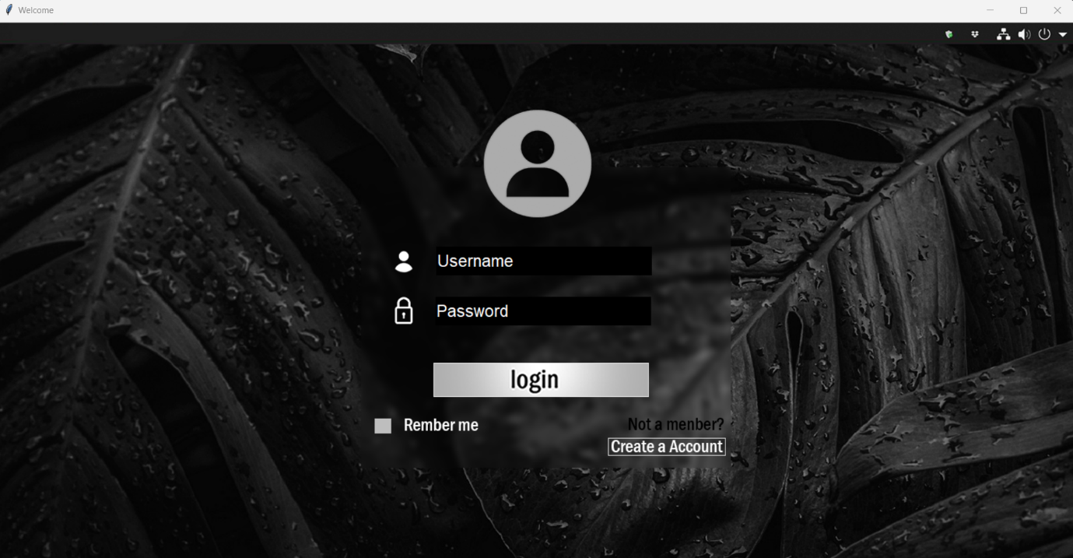

**Create Account:**

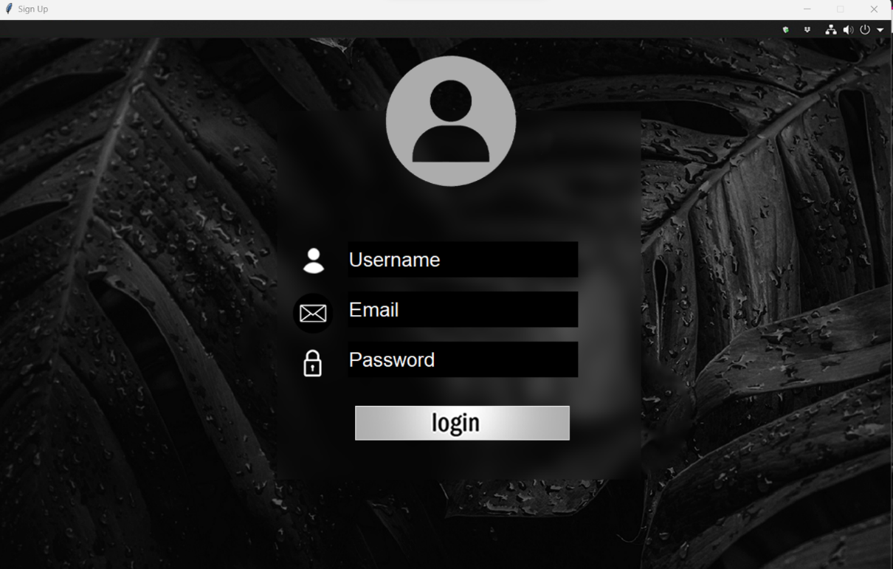

**Login:**

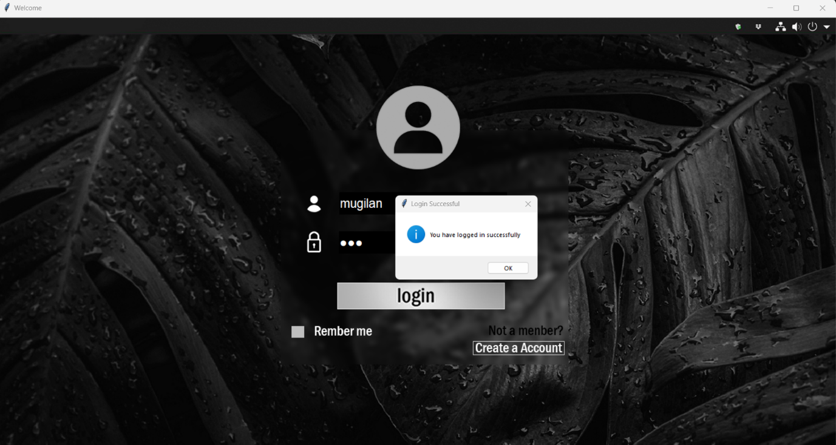

**Wrong login:**

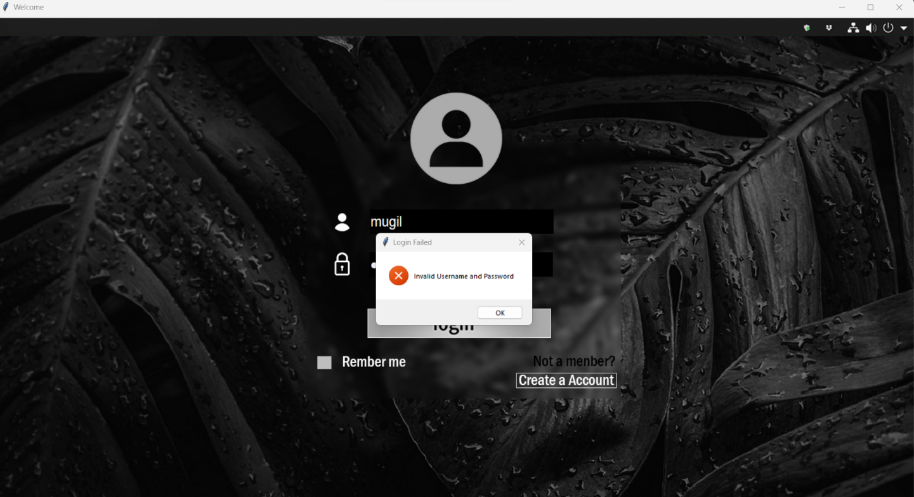

**Window:**

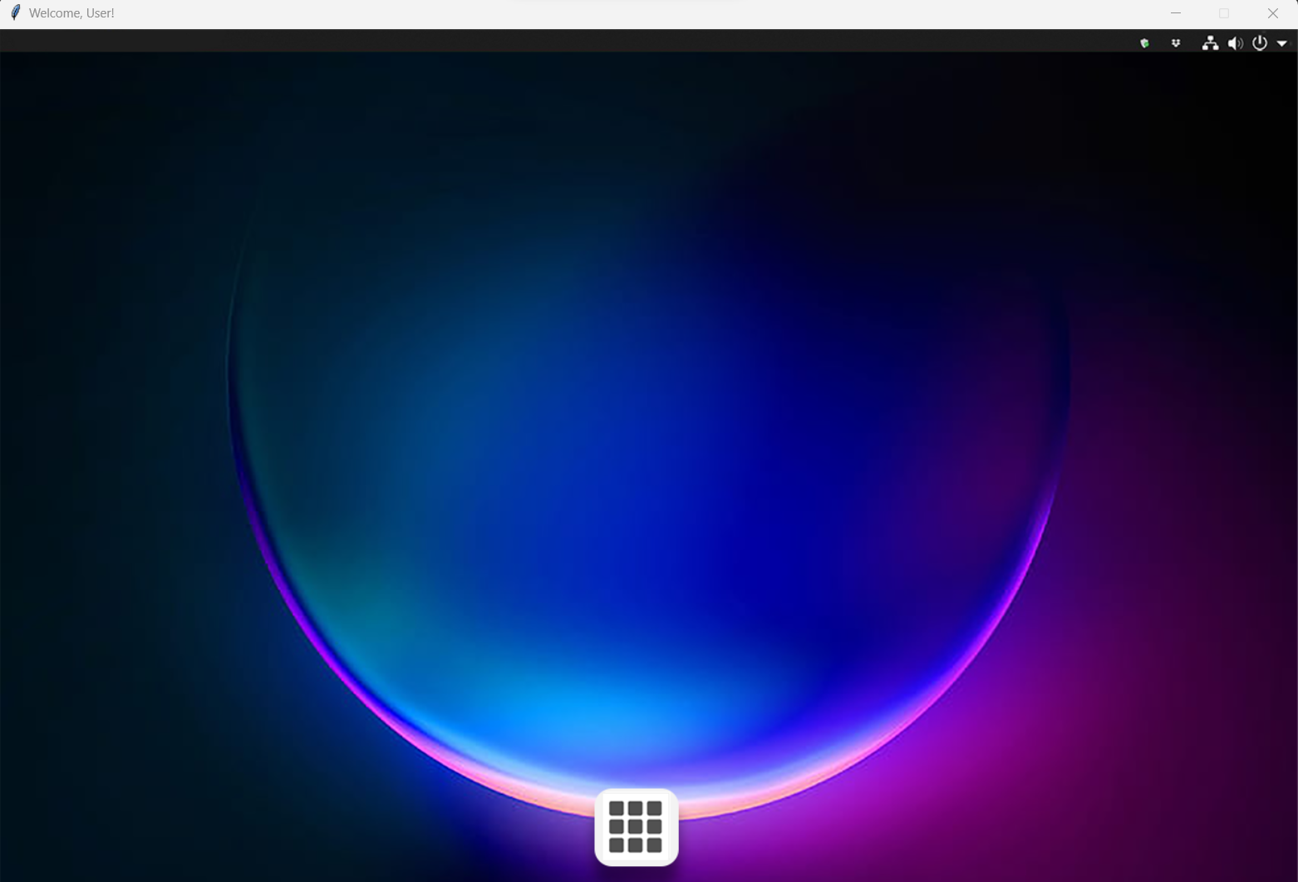

**Apps:**

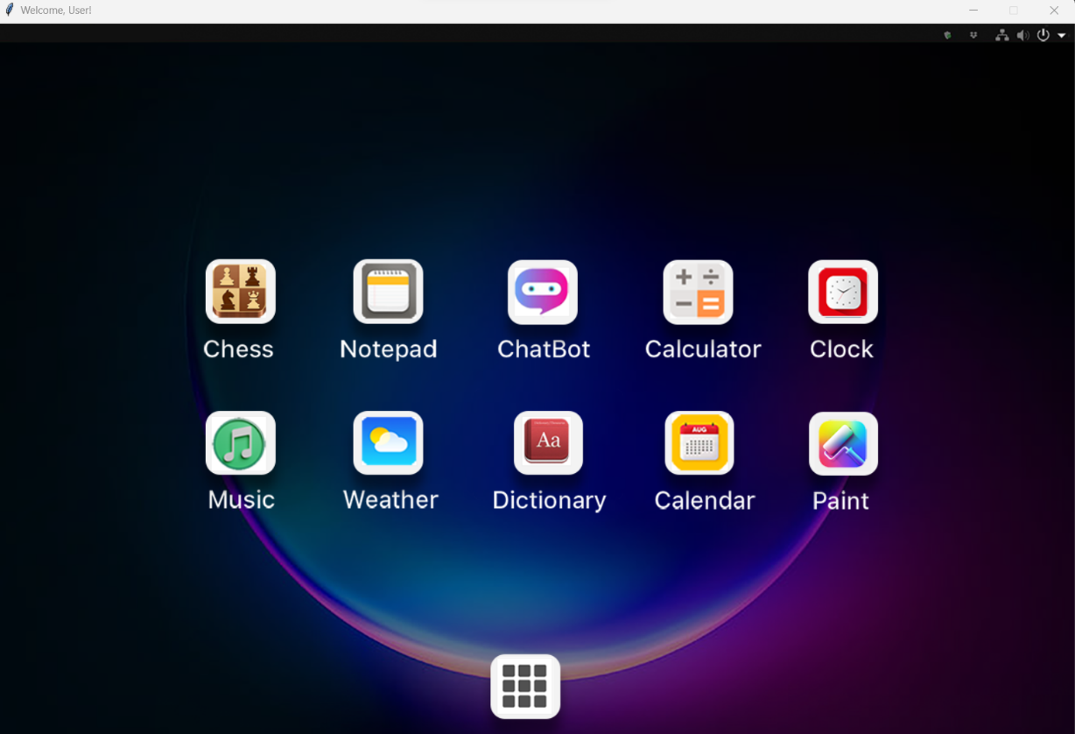

**Notepad:**

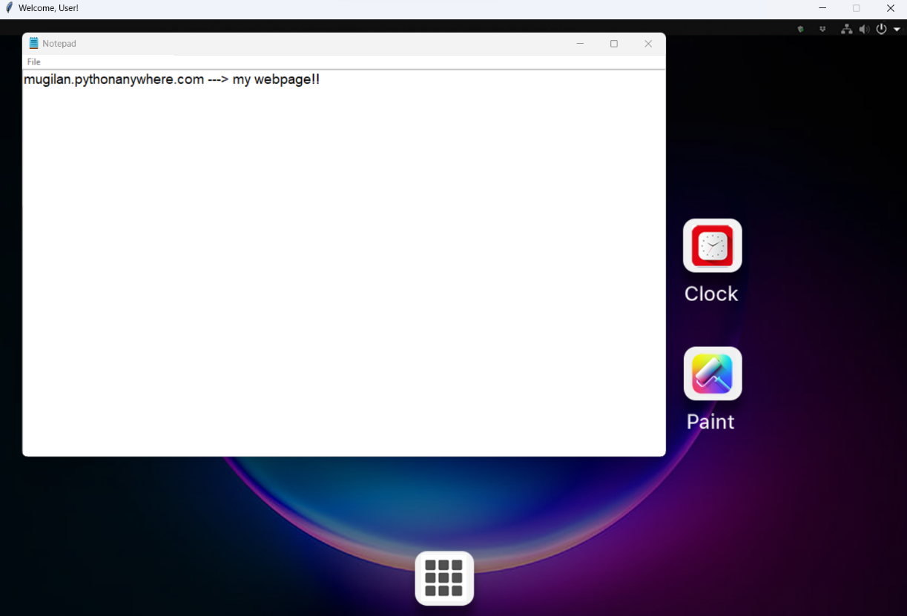

**Chatbot:**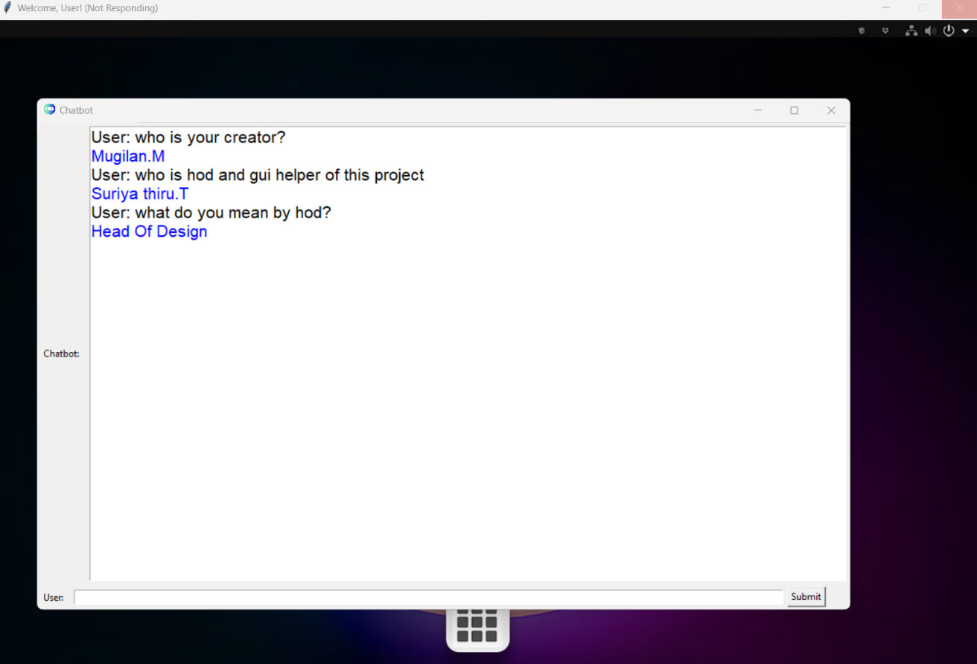

**Calculator:**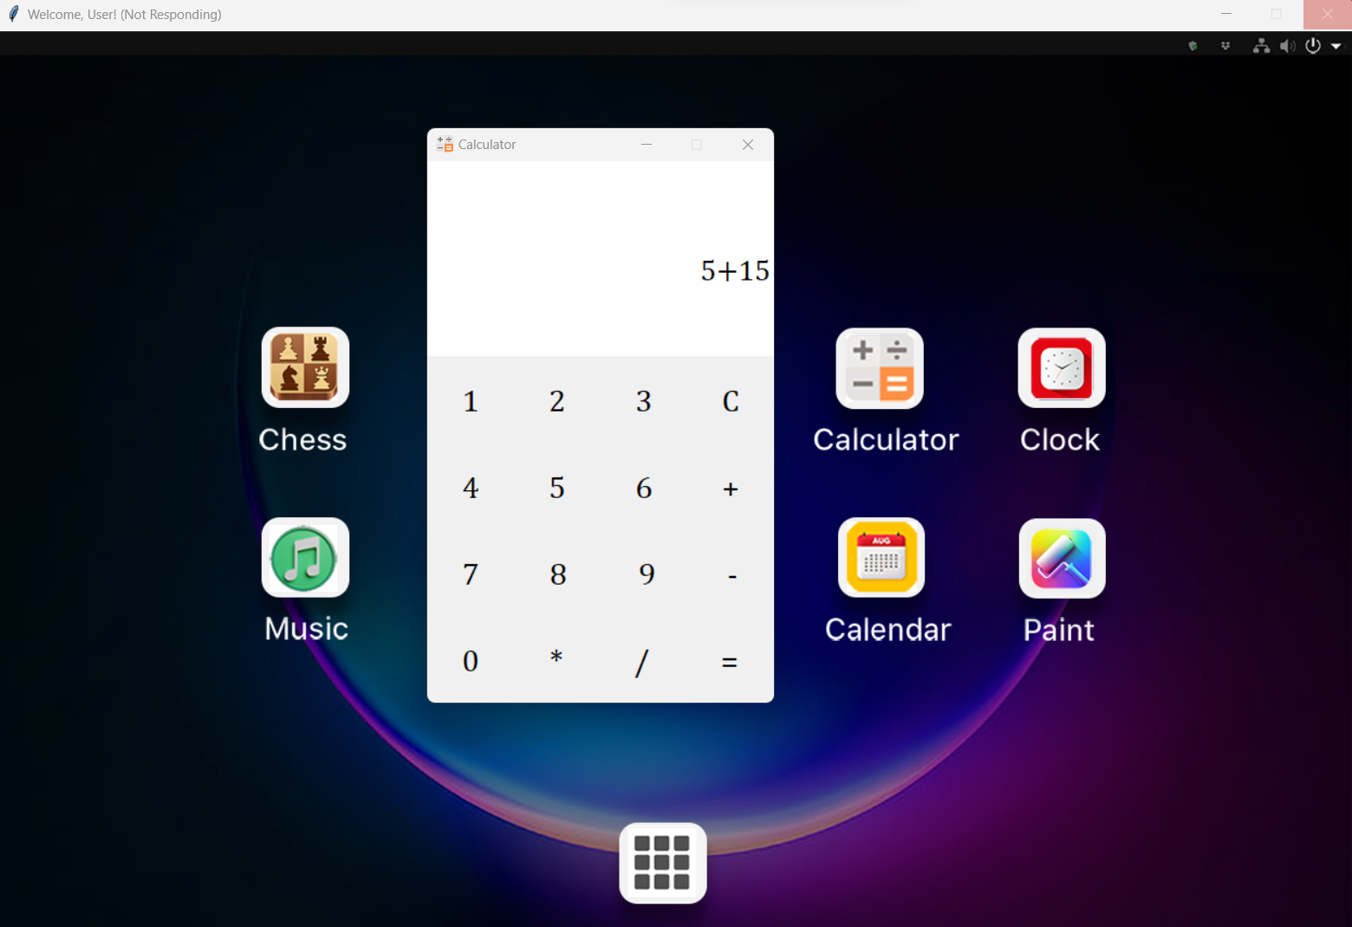

**Music_player:**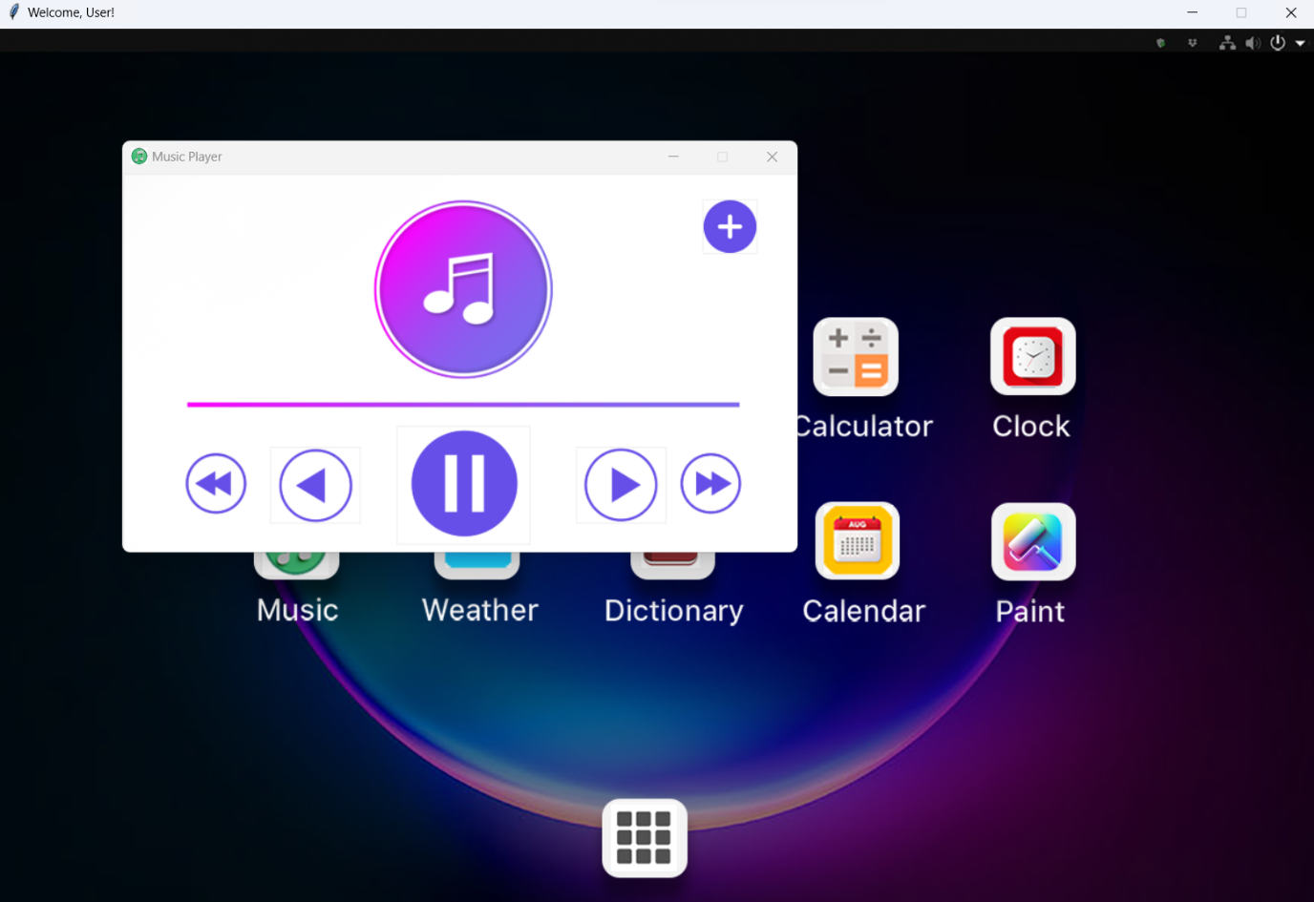

**Clock:**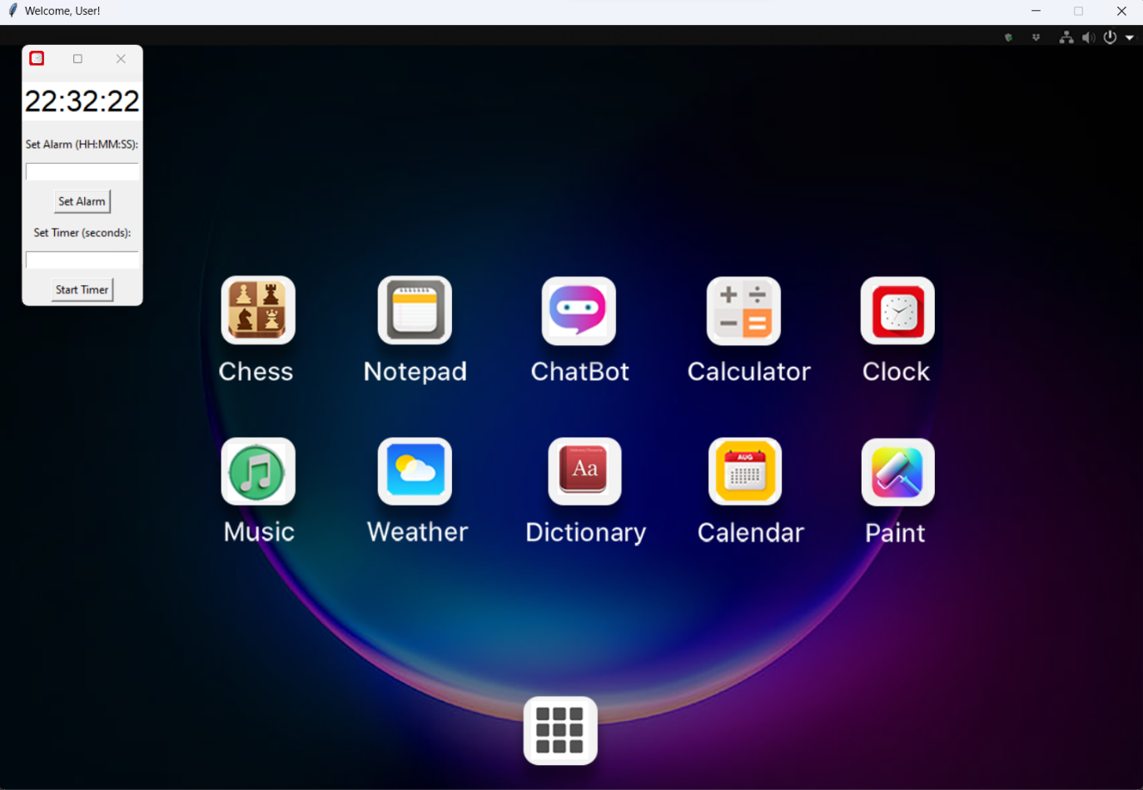

**Weather:**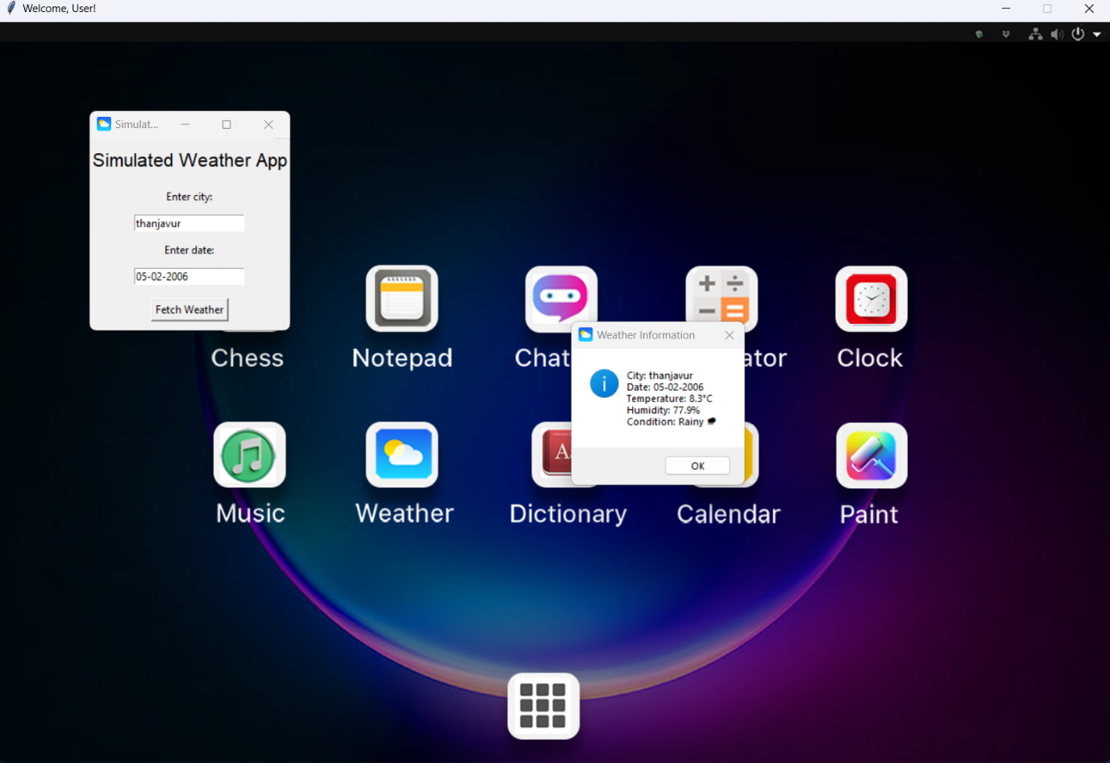

**Dictionary:**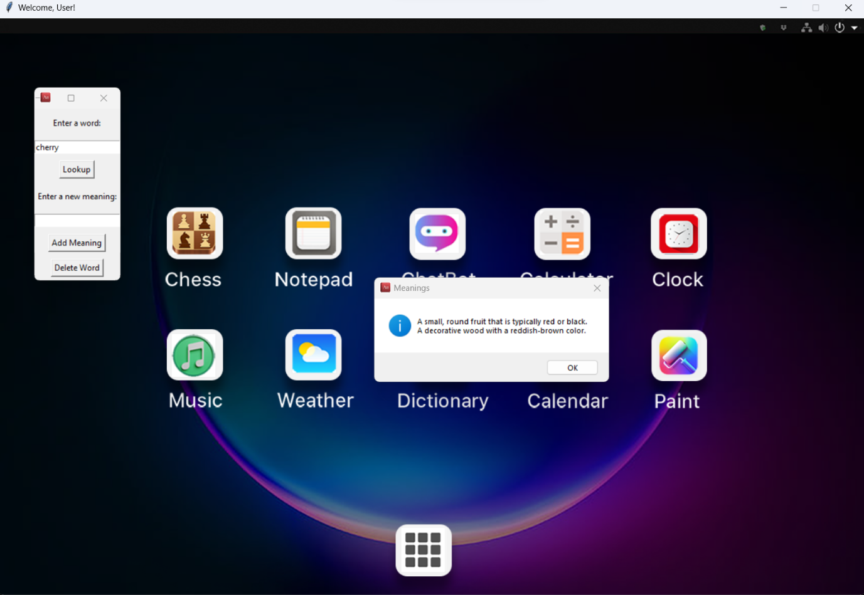

**Calendar:**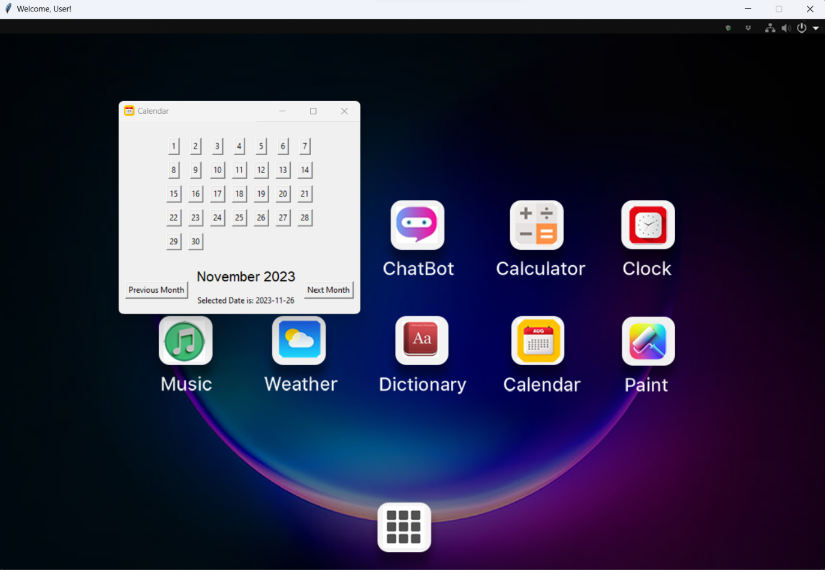

**Paint:**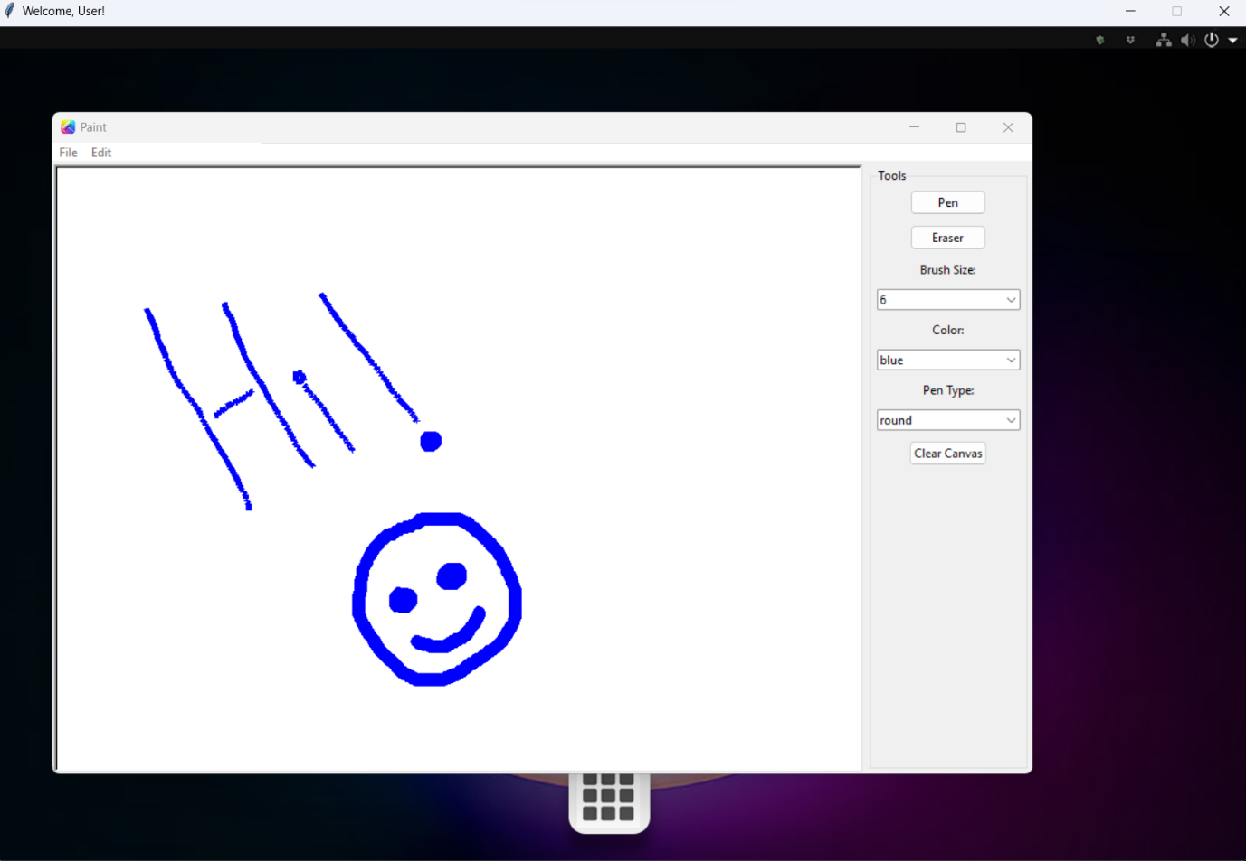

## BIBLIOGRAPHY

1. **Computer science with Python - Class XI & XII by: Sumita Arora**
2. **https://www.stackoverflow.com**
3. [**https://www.geeksforgeeks.org**](https://www.geeksforgeeks.org)
4. [**https://github.com**](https://github.com)
5. [**https://www.w3schools.com**](https://www.w3schools.com)
6. **https://www.tutorialspoint.com**